To Bracket or Not Bracket: Experiments in Gamification in the Wilds of Technical Communication

Brett Oppegaard
University of Hawai’i at Manoa
2550 Campus Road
Honolulu, HI 96822
+1 808-956-3340
brett.oppegaard@hawaii.edu
Thomas Conway
University of Hawai’i at Manoa
1776 University Avenue
Honolulu, HI 96822
+1 808-375-7092
tconway@hawaii.edu
Megan Conway
University of Hawai’i at Manoa
1776 University Avenue
Honolulu, HI 96822
+1 808-956-6166
mconway@hawaii.edu

ABSTRACT
“Gamification” research has evolved and grown dramatically in recent years, gaining popularity across disciplines. While such efforts have generated headway in many respects, and in various directions, from conceptual understandings to user studies, the field could benefit from more work focused upon use in research methodologies at the nexus of practice and theory. This paper, in turn, reflects upon such an experiment aimed at the design and application of gamification techniques within a typical technical-communication context. In this case, subject matter experts within the National Park Service were being asked to improve accessibility of their site brochures by audio describing them. During this training, they were given an overview of audio description, as a process, as well as introduced to a prototype web tool and then asked to use that tool to create the description for their site brochure. Unlike previous training exercises with other parks in this project, though, this group also was organized by sites into a tournament bracket, in which pairs of parks competed against each other in exercises designed to create comparable audio description. The winner of each round, as determined by an independent panel of judges, advanced to the next round, spurred by the promise of fun Hawaiian-themed prizes at the end. This gamification strategy appeared to generate more data, and more research-focused data, than the previous training exercises we have offered, per user. It also apparently engaged many, in various evident ways. But it also seemed to disenfranchise some as well, who dropped out of this voluntary training, creating a mix of results, which will be outlined in this paper.
Categories and Subject Descriptors
L.3.6 [Science and Technology of Learning]: Methodology/Tools/Technology – Technology Enhanced Learning.
General Terms
Design, Experimentation.
Keywords
Gamification, audio description, accessibility, information design, cross-modal translation, National Park Service, disability studies.

AUDIO DESCRIPTION AS A CONTEST
For more than 30 years, the U.S. National Park Service (NPS) has been struggling to address federal mandates that require the availability of equivalent learning media on site for those with disabilities, such as blindness or low vision. While NPS sites offer much visual media, in many forms – including videos, visitor-center exhibits, and wayside signs – this research project has been focused strictly on the unique paper brochures offered at each place. One objective of this research project has been to find a practical path for the NPS to translate its roughly 400 purely visual and silent (paper-based) brochures into equivalent acoustic versions using a captioning-like process called audio description. For this work, our research team has custom-built a web-based tool, www.unidescription.org, which includes an online training center and forum. To user test this approach, we had organized and conducted two earlier and similar training sessions for parks, as a way for them to learn and use the UniD system, starting with three sites in Round 1 and eight parks in Round 2. For Round 3, though, we had many more parks wanting to participate (28) and an ambition to use gamification techniques to increase the engagement and quality of our training and production processes, leading to more and better data per park. With NCAA basketball’s upcoming March Madness as an inspiration, we decided to create our own sort of tournament bracket and incorporate it into the process, which we dubbed a “Descriptathon.” During this three-day training session, we gave our usual spiels about audio description. We gave the parks guidance and objectives for finishing their brochures, like we did before. Yet in this round, we also added a generally light-hearted competition to see how that affected the Descriptathon dynamic. In that process, we discovered many positive aspects associated with such a structure, including what we perceived as increased camaraderie and aesthetic motivations. We also had a few dropouts, which might or might not be attributable to the perception of an “electronic whip.”
Permission to make digital or hard copies of all or part of this work for personal or classroom use is granted without fee provided that copies are not made or distributed for profit or commercial advantage and that copies bear this notice and the full citation on the first page. Copyrights for components of this work owned by others than the author(s) must be honored. Abstracting with credit is permitted. To copy otherwise, or republish, to post on servers or to redistribute to lists, requires prior specific permission and/or a fee. Request permissions from Permissions@acm.org.
SIGDOC '15, July 16 - 17, 2015, Limerick, Ireland
Copyright is held by the owner/author(s). Publication rights licensed to ACM.
ACM 978-1-4503-3648-2/15/07…$15.00
DOI: http://dx.doi.org/10.1145/2775441.2775463

Gamification as a methodology
Interest in gameplay to improve human processes is not new, by any means, but it did surge as an idea again in the mid-2000s, when a convergence of new mobile and web technologies intersected with evolving digital business models (Bogost, 2016; McGonigal, 2011; Nacke & Deterding, 2016; Walz & Deterding, 2015). Gamification, as the term du jour, has been thought to drive behavior in situations outside of games, including in serious contexts, by, among other outcomes, spurring innovation, increasing engagement, and raising efficiency (Rauch, 2013). Technical communication is a natural home for gamification studies, because of crossover interests in interface design, information management, and systems development; game design also revolves around concepts common in the academic field’s practices, such as iterative design, rapid prototyping, and user testing (deWinter & Vie, 2016). In this scholarly arena, researchers now are moving past the fundamental questions of definitions and motivations into inquiries about how such research should be done, when, and when not, including within that scope the challenges, heuristics, tools and methods of designing and implementing gamification techniques (Deterding, Björk, Nacke, Dixon, & Lawley, 2013; Nacke & Deterding, 2016). This effort is part of that inquiry.

A “GAMIFIED” METHOD
Similar to a sports tournament, National Park Service sites were paired in this process and told they would be competing to see who could write the better audio description of a provided media artifact. Each round offered a new artifact to describe, with an increasing level of difficulty, starting with a photographic portrait of Thomas Edison and followed by a landscape photo in Denali National Park and Preserve, an Everglades National Park collage, and a Yellowstone National Park map, all retrieved as some of the most challenging examples from our Round 2 training. After getting the necessary permissions, we used the forum on the web tool (www.unidescription.org/forum) as a way to catalog the various responses and to open up the process and data to the general public.
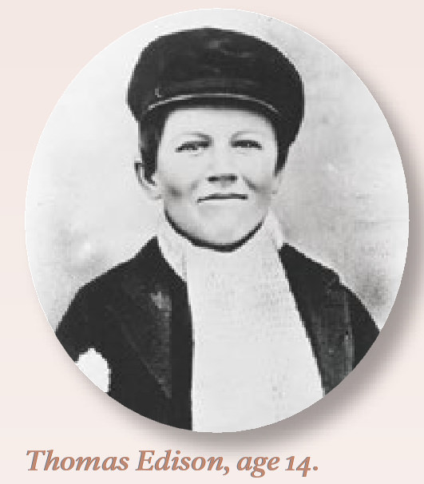
In other words, the Edison portrait was one of our most debated and difficult artifacts to audio describe in Round 2 of our training (when we were working with Thomas Edison National Historical Park), so we brought it back to Round 3, gave it to this new group of park staff (none affiliated with that park) and had them give it a try, to see the responses and how they might differ. The 33 responses varied widely (some participants responded multiple times) and ranged from a relatively straightforward description, such as:
Figure 1. Thomas Edison portrait.
Courtesy of The National Park Service.

.

A black and white round photo shows a young Thomas Edison at age 14. He gazes directly and confidently straight at the camera, while wearing a newsboy cap, scarf, and jacket, and almost smiling.
To more interpretive impressions, such as:
Aged fourteen, Thomas Edison, dressed in a knitted scarf, workman's cap, and jacket, sits with a confident half-smile on his face. His eyes reveal his precocious intelligence, maturity, and, at the same time, the burden of responsibilities he bears. He is working already. He studies at home when he can, but does not attend school. He suffers from hearing problems, but his force of personality does not let that deter him. The young man will be an inventor and businessman, and will need the toughness and resourcefulness he honed in these formative years.
At the end of each round, a panel of three judges (the Media Accessibility Coordinator for Harpers Ferry Center, Michele Hartley, and two independent consultants, specializing in audio description, Sina Bahram and Annie Leist) picked a winner from each pairing. As half of the field was eliminated from the main competition in each round, those who were not part of the main tourney anymore were placed into a consolation bracket, which we called “People’s Choice.” Those parks competed against everyone else eliminated each round, with the opportunity to rise back into a form of contention. In the final round, this tournament therefore had two victors crowned, one from the main tourney and one from the People’s Choice tourney. The completed bracket shows the progression, in which Valley Forge won the main tourney and the author of the NPS System Map emerged as the People’s Choice.
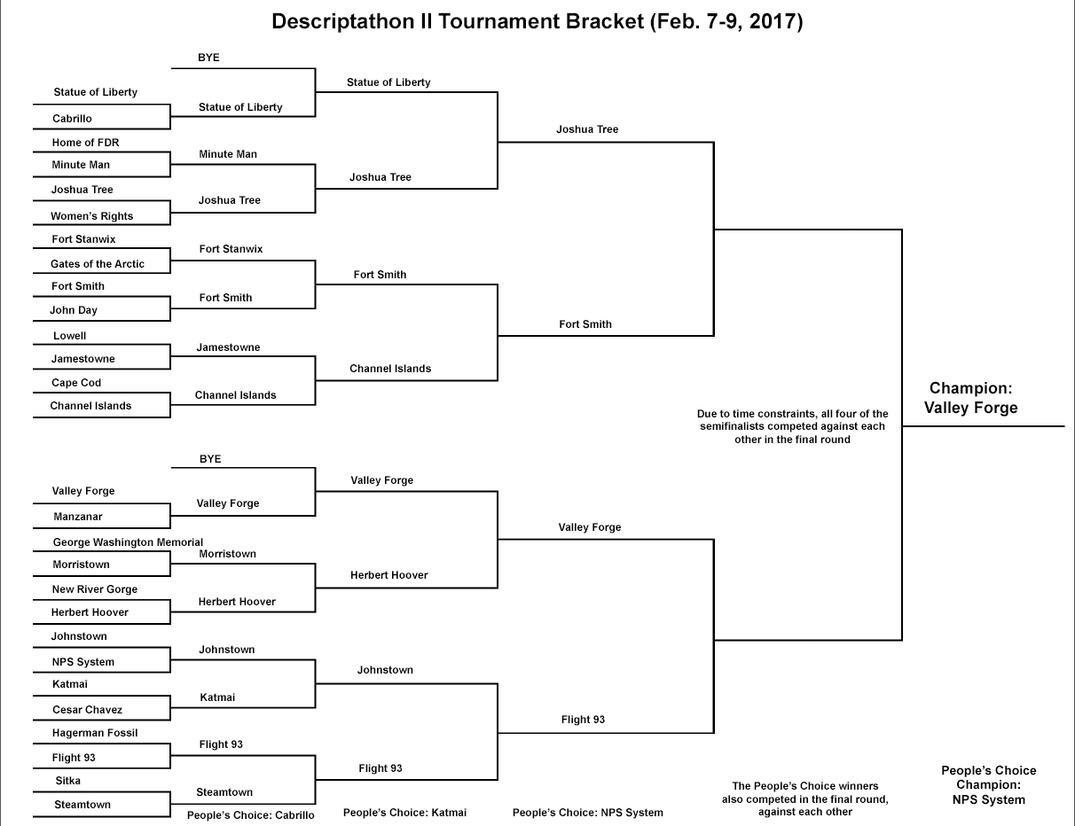
Figure 2. Completed Descriptathon bracket.

FINDINGS
The “gamification” approach described here did produce an enormous amount of data, with the description responses of the contest, including 31 forum threads and 293 responses,
plus 24 out of 28 completed (or mostly completed) their first drafts of the description of their park brochure.

d larger sample size and the refined coding schema of Round 3 had measureable effects on our understandings of the Nati

DISCUSSION
The Unigrid design system, in turn, provides a robust substructure to National Park Service brochures. If a visitor looks at
As many scholars have stressed, gameplay has to be a voluntary activity (Huizinga, 1955).
levels.

ACKNOWLEDGMENTS
Our thanks to the National Park Service, in particular Michele Hartley, who served as our liaison with these sites across the country, as well as to accessibility consultants Sina Bahram and Annie Leist, and to UH research assistants Philipp Jordan and Tuyet Hayes, who performed the experiment’s groundwork.

REFERENCES
- Bogost, I. (2016). Play Anything: The Pleasure of Limits, the Uses of Boredom, and the Secret of Games. New York, NY: Basic Books.
- Deterding, S. (2014). Eudaimonic design, or: Six invitations to rethink gamification. In M. Fuchs, S. Fizek, P. Ruffino, & N. Schrape (Eds.), Rethinking Gamification (pp. 305-331). Luneburg, Germany: Meson Press.
- Deterding, S., Björk, S. L., Nacke, L. E., Dixon, D., & Lawley, E. (2013). Designing gamification: creating gameful and playful experiences. Paper presented at the CHI'13 Extended Abstracts on Human Factors in Computing Systems, New York, NY.
- deWinter, J., & Vie, S. (2016). Games in Technical Communication. Technical Communication Quarterly, 25(3), 151-154.
- Huizinga, J. (1955). Homo Ludens: A Study of the Play Element in Culture. Boston: Beacon Press.
- McGonigal, J. (2011). Reality is broken: Why games make us better and how they can change the world. London: Penguin Books.
- Nacke, L. E., & Deterding, S. (2017). The maturing of gamification research. Computers in Human Behavior, 71, 450-454.
- Rauch, M. (2013). Best practices for using enterprise gamification to engage employees and customers. Paper presented at the International Conference on Human-Computer Interaction, Las Vegas, NV.
- Walz, S. P., & Deterding, S. (2015). The gameful world: Approaches, issues, applications. Cambridge, MA: MIT Press.
- XXXXXXXXPress.

